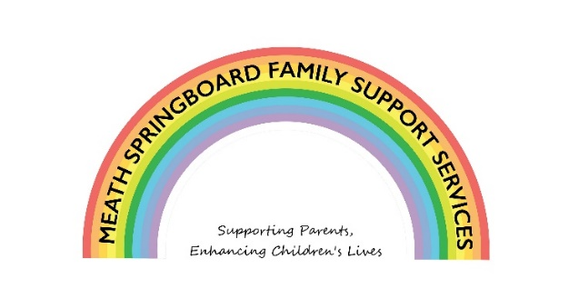

Covid Response to Children with Additional Needs
Funded by The Toy Show Appeal
Strengths and Difficulties Questionnaire (P 4 – 17)
For each item please mark the box for Not True, Somewhat True or Certainly True. It would help us if you answered all items as best you can even if you are not absolutely certain or the item seems daft! Please give your answers on the basis of the child’s behaviour over the last 6 months.
Child’s Name ……………………………………………………………………….
Date of Birth ……………………………………………… Male/Female
 | Not True | Somewhat True | Certainly True
Considerate of other people’s feelings
Restless, cannot stay still for long
Often complains of headaches, stomach ache or sickness
Shares really well with others children (food, games, pens etc)
Often has temper tantrums or hot tempers
Rather solitary, tends to play alone
Generally obedient, usually does what adults request
Many worries, often seems worried
Helpful if someone is hurt, upset or feeling ill
Constantly fidgeting or squirming
Has at least one good friend or more
Often fights with other children or bullies them
Often unhappy, downhearted or tearful
Generally liked by other children
Easily distracted, concentration wanders
Nervous and clingy in new situations, easily loses confidence
Kind to younger children
Often lies or cheats
Picked on or bullied by other children
Often volunteers to help others (parents, teacher, children)
Thinks things out before acting
Steals from home school or elsewhere
Gets on better with adults than with other children
Many fears, easily scared
Sees tasks through to the end, good attention span

Overall, do you think that your child has any difficulties in one or more of the following areas:
Emotions, concentration, behaviour or being able to get on with other people?
No | Yes – minor difficulties | Yes -definite difficulties | Yes – severe difficulties

If you have answered “Yes”, please answer the following questions about these difficulties:

- How long have these difficulties been present?
Less than a month | 1-5 months | 6-12 months | Over a year

- Do the difficulties upset or distress your child?
Not at all | Only a little | Quite a lot | A great deal

- Do the difficulties interfere with your child’s everyday life in the following areas?
 | Not at all | Only a little | Quite a lot | A great deal
Home Life
Friendships
Classroom Learning
Leisure Activities

- Do the difficulties put a burden on the family as a whole?
Not at all | Only a little | Quite a lot | A great deal

Signature ………………………………………………….. Date ………………………………….
Mother/Father/Other (please specify): ………………………………………………………..

Thank you very much for your help

