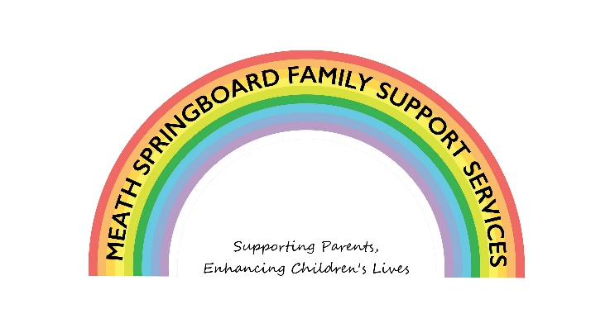

Covid Response to Children with Additional Needs
Funded by The Toy Show Appeal
REFERRAL FORM
Section 1: Parent’s Details

Mother | Father
Name: | Name:
Address: | Address (if different):
Mobile: | Mobile:
Email: | Email:
Legal Guardian: YES ⁫ NO ⁫ | Legal Guardian: YES ⁫ NO ⁫
Who do child(ren) reside with:

Please tick if you are linked with any of the following services:

Meath Springboard Family Support Services
Trim Family Resource Centre
Kells People’s Family Recourse Centre
East Coast Family Resource Centre
Navan Family Resource Centre (Tusla PPFS)

Section 2: Services You Require for your Child

 | Type of service | Please Tick
 | Counselling/Play Therapy | ⁫
 | Confident Me Programme | ⁫

Section 3: Children’s Details (please tick beside the child you are referring)

Name | Date of Birth | Referred for service
What are the reasons for this referral being made?
__________________________________________________________________________
__________________________________________________________________________
__________________________________________________________________________
__________________________________________________________________________

Are there any other agencies or services working with the family?
__________________________________________________________________________
__________________________________________________________________________
__________________________________________________________________________

By signing below you are declaring that you are giving consent for the information on this form to be stored by us electronically using an online storage. The information will be used to ensure Meath Springboard can provide an effective service to the family, which will include making contact with the referrer and the parents. Meath Springboard will treat all information with the utmost respect and adheres to General Data Protection Regulations 2018. Please contact us at info@springboardnavan.ie for more information on our Data Protection Policies and Procedures.

Print Name:__________________________ Signature:___________________________

Date: _______________________

If the referrer is not a member of the family please complete the following:
Name: | Profession:
Tel: | Email:
Nature of contact with family:_______________________________________________
_________________________________________________________________________

Please return the completed referral form to Meath Springboard Family Support Services, Mangan House, Clonmagadden Road, Windtown, Navan, Co Meath, C15 X70F
