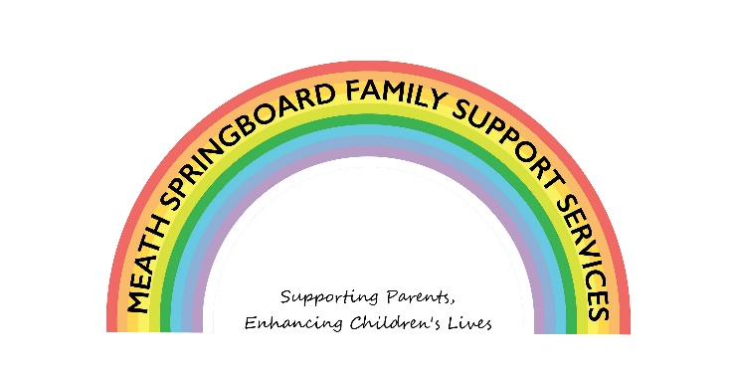

Covid Response to Children with Additional Needs
Funded by The Toy Show Appeal
Parental Consent Form for Play Therapy and Counselling
Names of Both Parents/Guardian: _____________________________
Address of Both Parenta/Guardian: _____________________________
_____________________________
_____________________________
_____________________________
Contact Number of both Parents/Guardian: _____________________________
Name of Child(ren) to avail of service: _____________________________

We ______________________________________________ (Parents/Guardian) of ___________________________ (child’s name), give consent for the child named to attend Play Therapy/Counselling.
Signatures of Both Parents/Guardian:

___________________________________ _________________________________

