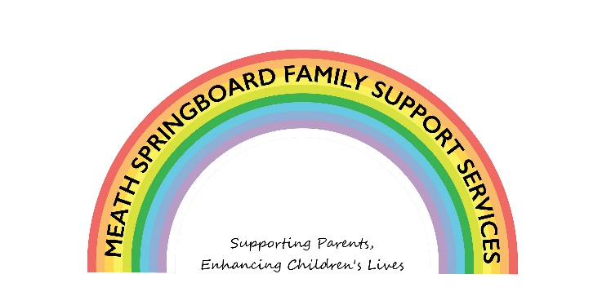

Covid Response to Children with Additional Needs
Funded by The Toy Show Appeal
Client Induction Information

Name:
Address
Tel No:
Children’s Names &
Ages

Confidentiality & Child Protection
Our work with you is confidential. However under the Children First Act 2015, if we become aware of children at risk of neglect, harm or abuse we are duty bound to contact the Child Protection Social Work Department and or the Gardaí. Where appropriate we will discuss our concerns with you ahead of making contact with the Social Workers and or the Gardaí. Our Child Protection and Confidentiality policies are available upon request.
I understand and accept confidentiality with Meath Springboard as outlined above;

Signed: __________________________ Date: _______________________

Your Information: Why, Where, How, What and When
Where: Meath Springboard FSS store all details of our work on a secure electronic filing system.
What: We keep records of calls, visits and any communications made in relation to our work with your family. In relation to therapy, we keep a record of appointments NOT therapy notes.
Why: We do this so we can ensure to provide a focused and supportive service and so we can verify the quantity of work carried out by our service to our funders. The time we keep records for is based on timelines for civil litigation.
When: We keep these electronic records for 3 years from date of closing (if only working with parent) or when a child reaches 21 years of age (if working directly with children).
Our Data Protection Policy that is available on request.
Sharing your information: at times we will support you or your family in working with other organisations. Some examples include the local county council, schools, primary care services, Child and Adolescent Mental Health Services. We only share information with other agencies as a part of supporting you in achieving your goals. In the event that we are going to discuss your family with another agency/person we will only do so with your consent.
Strengths & Difficulties Questionnaire: the purpose of completing these questionnaires at the beginning and end of your child’s involvement is to track the effectiveness of Confident Me and Play Therapy/Counselling/Psychotherapy as a response to the emerging needs in children across Meath. They will not be used to assess your child on an individual basis. Once the beginning and end questionnaire are completed and paired together, identifying information will be removed from them.
I understand and agree to the processing of my personal information by Meath Springboard FSSS
Signed: __________________ Date: __________________
Witnessed by: ____________________ Date: _________________________

Social Media, Photographs (specifically re Confident ME!)

Photographs: I ____________________ give consent for my photograph and photographs of my children (if they are participating in Springboard activities) to be taken by Springboard and used on social media or displayed in the premises with the understanding that I will not be tagged in any photograph. I can withdraw my consent to this at any stage.
Signed: __________________________ Date: _______________________

Parent Commitment Statement.

I __________________ have discussed this document with ________________and I am satisfied with its content. I agree to work and co-operate to the best of my ability with Meath Springboard Family Support Services and other professionals I may be linked in with through this service.

_____________________ _________________________
Parent Date

Contribution
Please tick the option you are availing of

Confident Me:
Paying €25 lump sum
Paying 5 weekly instalments of €5
Please make payment directly to service facilitating the programme

One to One Therapy:
Pay per session directly to therapist €10 €20 €30
Contribution must be agreed upon in advance with Meath Springboard or Partner Agency

