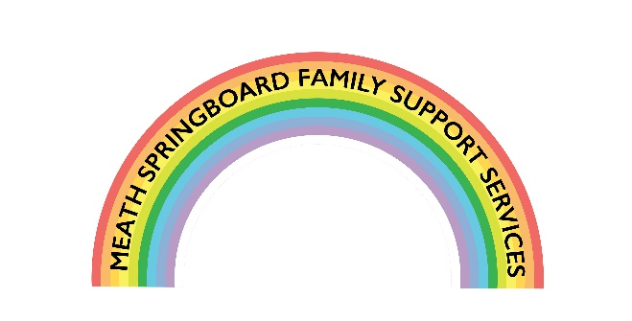

Supporting Families,
Enhancing Children’s Lives

REFERRAL FORM
Section 1: Parent’s Details

Mother | Father
Name: | Name:
Address: | Address (if different):
Mobile: | Mobile:
Email: | Email:
Legal Guardian: YES ⁫ NO ⁫ | Legal Guardian: YES ⁫ NO ⁫
Who do child(ren) reside with:

Section 2: Services You Require

 | Type of service | Please Tick
Child | Counselling/Play Therapy | ⁫
 | Access Support  Confident Me Programme | ⁫  ⁫
Parent | Counselling | ⁫
 | Parenting Course | ⁫
 | Connect Women’s Group | ⁫
 | He’s My Dad Group  Young Mum’s Group | ⁫  ⁫
Family | Tailored Programme of Family Support | ⁫

Section 3: Children’s Details (please tick beside the child you are referring)

Name | Date of Birth | Referred for service

What are the reasons for this referral being made?
__________________________________________________________________________
__________________________________________________________________________
__________________________________________________________________________
__________________________________________________________________________

What do you hope Springboard can offer the family?
__________________________________________________________________________
__________________________________________________________________________
__________________________________________________________________________
__________________________________________________________________________

Are there any other agencies or services working with the family?
__________________________________________________________________________
__________________________________________________________________________
__________________________________________________________________________

By signing below you are declaring that you are giving consent for the information on this form to be stored by us electronically using an online storage. The information will be used to ensure Meath Springboard can provide an effective service to the family, which will include making contact with the referrer and the parents. Meath Springboard will treat all information with the utmost respect and adheres to General Data Protection Regulations 2018. Please contact us at info@springboardnavan.ie for more information on our Data Protection Policies and Procedures.

Print Name:__________________________ Signature:___________________________

Date: _______________________

If the referrer is not a member of the family please complete the following:
Name: | Profession:
Tel: | Email:
Nature of contact with family:_______________________________________________
_________________________________________________________________________

Please return the completed referral form to Meath Springboard Family Support Services, Mangan House, Clonmagadden Road, Windtown, Navan, Co Meath, C15 X70F

